OBSERVÁ LA IMAGEN, ELEGI 4 DIBUJOS Y ESCRIBILOS EN LOS RENGLONES.
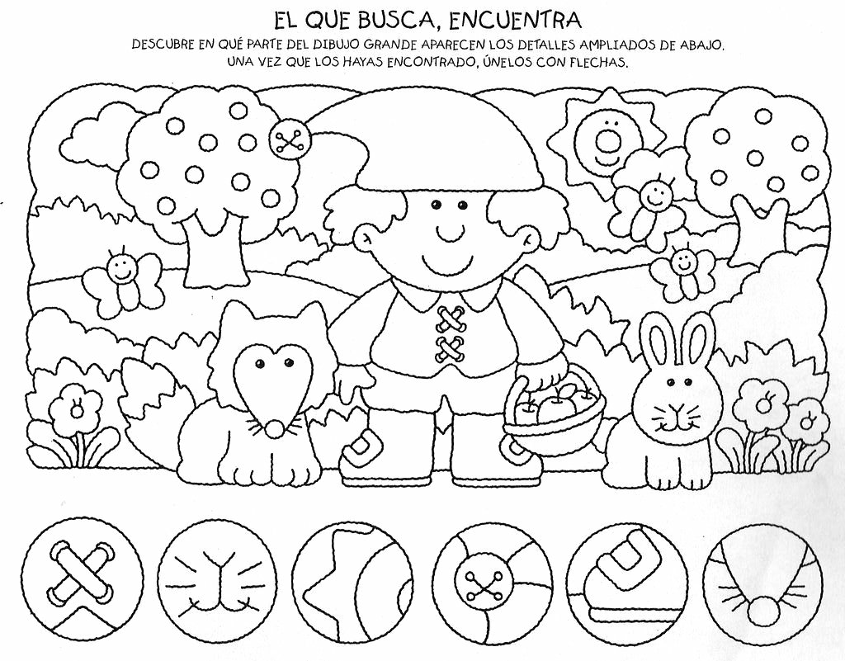
________________________________________________________________________
________________________________________________________________________
________________________________________________________________________
________________________________________________________________________
OBSERVÁ LA IMAGEN, ELEGI 4 DIBUJOS Y ESCRIBILOS EN LOS RENGLONES.

________________________________________________________________________
________________________________________________________________________
________________________________________________________________________
________________________________________________________________________

